Purpose: How to integrate eclipse based plugin named as EGIT with Domino Designer version 12.0.1
What is EGit?
EGit is a distributed Source Code Management tool, which means every developer has a full copy of all history of every revision of the code, making queries against the history very fast and versatile.
Download the Egit’s latest version (6.1.0.202203080745-r) from the below link
https://wiki.eclipse.org/EGit/FAQ#Where_can_I_find_older_releases_of_EGit.3F
Steps for Installation of EGIT plug-in in Domino Designer 12.0.1:
- File-Application-Install
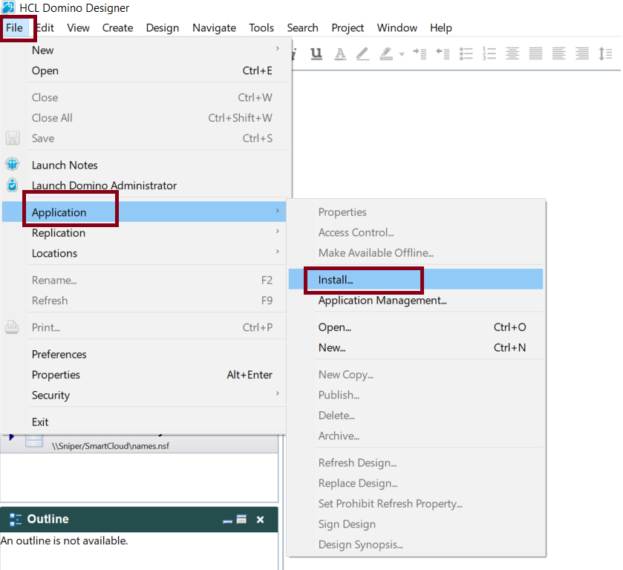

- Select the Application Location as below which is downloaded from either the eclipse site or Cudar
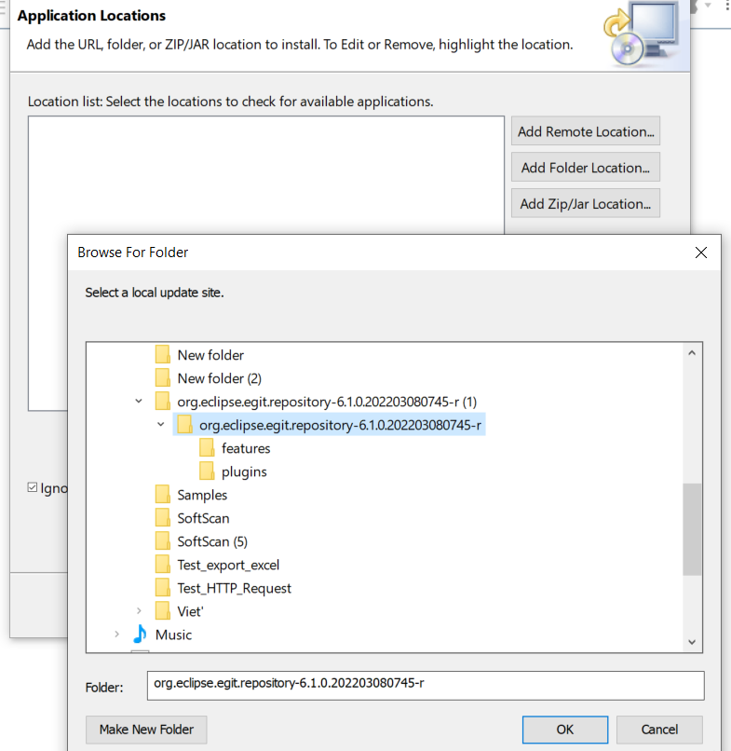

- Select the location and click on finish button.
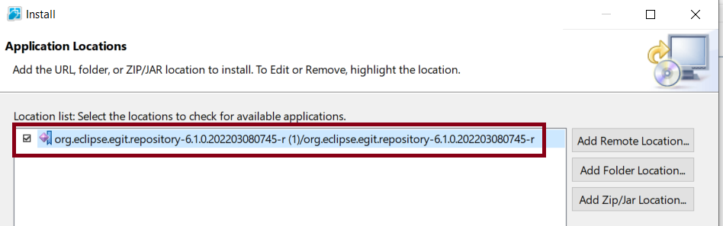

- Click on checkbox then Search Results will prompt will occur with the below error.

Error: “Git integration for Eclipse - Task focused interface (6.1.0.202203080745-r) requires feature "org.eclipse.mylyn.team_feature (3.20.0)", or later version.”
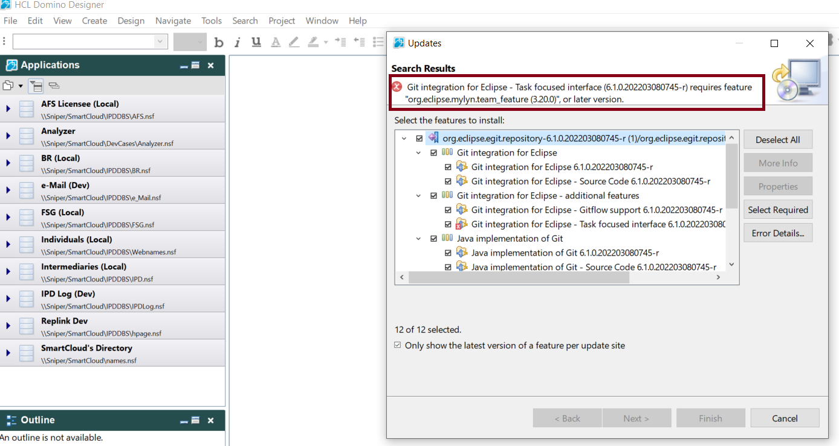

Tried the same installation with EGit 5.13.0.202109080827-r & 5.12.0.202106070339-r but facing the same issue.
Git integration for Eclipse - Task focused interface (5.13.0.202109080827-r) and (5.12.0.202106070339-r)requires feature "org.eclipse.mylyn.team_feature (3.20.0)", or later version.
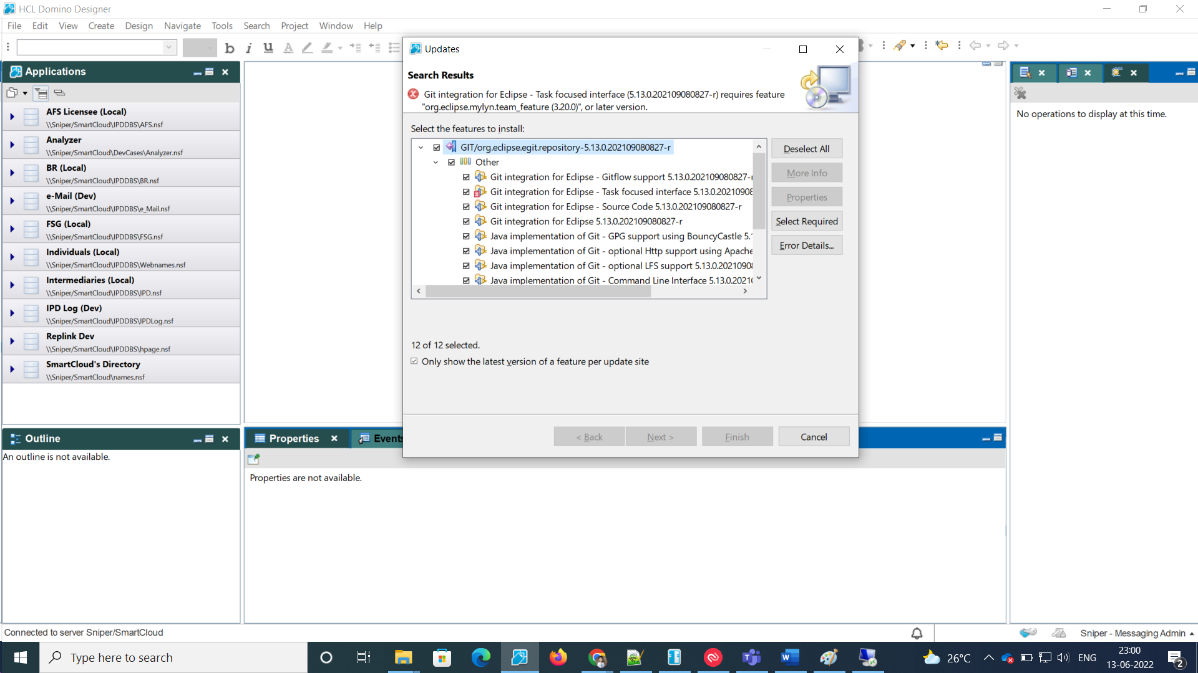

Error: “Git integration for Eclipse - Task focused interface (6.1.0.202203080745-r) requires feature "org.eclipse.mylyn.team_feature (3.20.0)", or later version.”

To resolve the above error we tried downloading and installing the mylyn-3.20.0.v20160608-1917 from below link

https://www.eclipse.org/mylyn/downloads/archive.php

To resolve this error we tried to install the mylyn-3.25.2.v20200831-1956

Error Faced: Mylyn Context Connector: C/C++ Development (5.21.2.v20200828-1617) requires feature "org.eclipse.cdt.platform (7.0.0)", or later version.

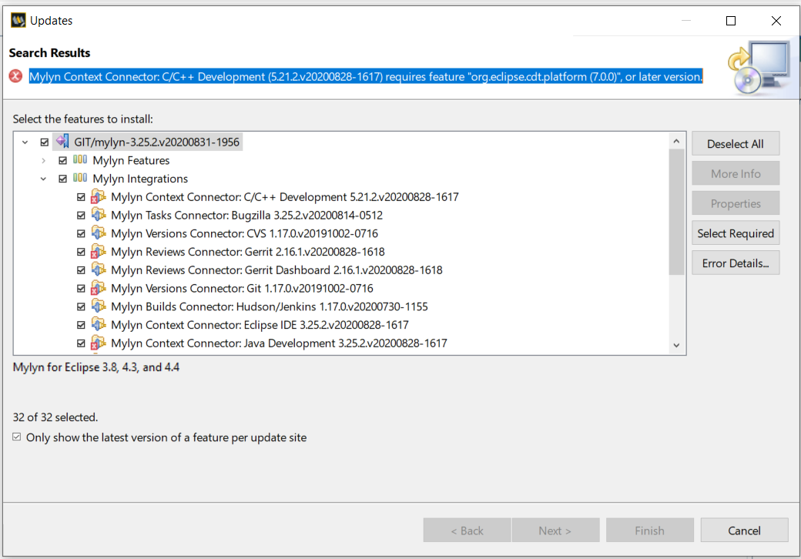

- To resolve the above error we tried to download and install the cdt-10.7.0.zip from the below link
https://www.eclipse.org/cdt/downloads.php

Again faced the below error

C/C++ Debug Adapter GDB Hardware Debugger Integration (10.7.0.202204200013) requires plug-in "org.apache.commons.io".

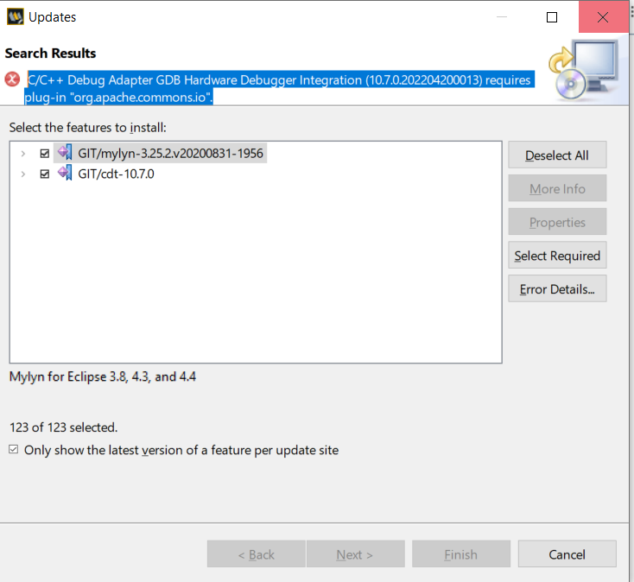

Conclusion:
- As per the HCL support guidelines the third party plugins are not supported here.

Also The Egit Plugin involves the multiple dependency levels on number of features and plugins
Egit’s latest version (6.1.0.202203080745-r) has dependency on below feature/plugin

org.eclipse.mylyn.team_feature (3.20.0) has dependency on below feature/plugin

org.eclipse.cdt.platform (7.0.0) has dependency on below feature/plugin

org.apache.commons.io

so on………………………………

We would like to conclude that EGIT plugin is supported with Domino designer 12.0.1.

